Lecture No.: 3rd
Course Code: ZOO 536
Course Name: Animal Physiology II
Teacher: Prabhjot Kaur

Topics covered: 1. Ovaries & Testis
2. Pineal gland & Thymus
3. Chemical categories of hormones and their mode of action
18.11 Ovaries and Testes
OBJECTIVE • Describe the location, hormones, and functions of the male and female gonads.
Gonads are the organs that produce gametes—sperm in males and oocytes in females. In addition to their reproductive function, the gonads secrete hormones. The ovaries, paired oval bodies located in the female pelvic cavity, produce several steroid hormones, including two estrogens (estradiol and estrone) and progesterone. These female sex hormones, along with follicle stimulating hormone (FSH) and luteinizing hormone (LH) from the anterior pituitary, regulate the menstrual cycle, maintain pregnancy, and prepare the mammary glands for lactation. They also promote enlargement of the breasts and widening of the hips at puberty, and help maintain these female secondary sex characteristics. The ovaries also produce inhibin, a protein hormone that inhibits secretion of FSH. During pregnancy, the ovaries and placenta produce a peptide hormone called relaxin (RLX), which increases the flexibility of the pubic symphysis during pregnancy and helps dilate the uterine cervix during labor and delivery. These actions help ease the baby’s passage by enlarging the birth canal.
The male gonads, the testes, are oval glands that lie in the scrotum. The main hormone produced and secreted by the testes is testosterone, an androgen or male sex hormone. Testosterone stimulates descent of the testes before birth, regulates production of sperm, and stimulates the development and maintenance of male secondary sex characteristics, such as beard growth and deepening of the voice. The testes also produce inhibin, which inhibits secretion of FSH. The detailed structure of the ovaries and testes and the specific roles of sex hormones are discussed in Chapter 28. Table 18.10 summarizes the hormones produced by the ovaries and testes and their principal actions.
18.12 Pineal Gland and Thymus
OBJECTIVES • Describe the location, histology, hormone, and functions of the pineal gland.
• Describe the role of the thymus in immunity.

Pineal Gland
It is a small endocrine gland attached to the roof of the third ventricle of the brain at the midline (see Figure 18.1). Part of the epithalamus, it is positioned between the two superior colliculi, has a mass of 0.1–0.2 g, and is covered by a capsule formed by the pia mater. The gland consists of masses of neuroglia and secretory cells called pinealocytes (pin-e¯-AL-oˉ-s¯ıts). The pineal gland secretes melatonin, an amine hormone derived from serotonin. Melatonin appears to contribute to the setting of the body’s biological clock, which is controlled by the suprachiasmatic nucleus of the hypothalamus. As more melatonin is liberated during darkness than in light, this hormone is thought to promote sleepiness. In response to visual input from the eyes (retina), the suprachiasmatic nucleus stimulates sympathetic postganglionic neurons of the superior cervical ganglion, which in turn stimulate the pinealocytes of the pineal gland to secrete melatonin in a rhythmic pattern, with low levels of melatonin secreted during the day and significantly higher levels secreted at night. During sleep, plasma levels of melatonin increase tenfold and then decline to a low level again before awakening. Small doses of melatonin given orally can induce sleep and reset daily rhythms, which might benefit workers whose shifts alternate between daylight and nighttime hours. Melatonin also is a potent antioxidant that may provide some protection against damaging oxygen free radicals. In animals that breed during specific seasons, melatonin inhibits reproductive functions, but it is unclear whether melatonin influences human reproductive function. Melatonin levels are higher in children and decline with age into adulthood, but there is no evidence that changes in melatonin secretion correlate with the onset of puberty and sexual maturation. Nevertheless, because melatonin causes atrophy of the gonads in several animal species, the possibility of adverse effects on human reproduction must be studied before its use to reset daily rhythms can be recommended.
Thymus
The thymus is located behind the sternum between the lungs. Because of the role of the thymus in immunity, the details of its structure and functions are discussed in Chapter 22. The hormones produced by the thymus—thymosin, thymic humoral factor (THF), thymic factor (TF), and thymopoietin (th¯ı-moˉpoy-E ¯-tin)—promote the maturation of T cells (a type of white blood cell that destroys microbes and foreign substances) and may retard the aging process.

Chemical Classes of Hormones
Chemically, hormones can be divided into two broad classes: those that are soluble in lipids, and those that are soluble in water. This chemical classification is also useful functionally because the two classes exert their effects differently.
Lipid-Soluble Hormones
The lipid-soluble hormones include steroid hormones, thyroid hormones, and nitric oxide.
1. Steroid hormones are derived from cholesterol. Each steroid hormone is unique due to the presence of different chemical groups attached at various sites on the four rings at the core of its structure. These small differences allow for a large diversity of functions.
2. Two thyroid hormones (T3 and T4) are synthesized by attaching iodine to the amino acid tyrosine. The presence of two benzene rings within a T3 or T4 molecule makes these molecules very lipid-soluble.
3. The gas nitric oxide (NO) is both a hormone and a neurotransmitter. Its synthesis is catalyzed by the enzyme nitric oxide synthase.
Water-Soluble Hormones
The water-soluble hormones include amine hormones, peptide and protein hormones, and eicosanoid hormones.
1. Amine hormones (a-ME ¯N) are synthesized by decarboxylating (removing a molecule of CO2) and otherwise modifying certain amino acids. They are called amines because they retain an amino group (—NH3). The catecholamines—epinephrine, norepinephrine, and dopamine—are synthesized by modifying the amino acid tyrosine. Histamine is synthesized from the amino acid histidine by mast cells and platelets. Serotonin and melatonin are derived from tryptophan.
2. Peptide hormones and protein hormones are amino acid polymers. The smaller peptide hormones consist of chains of 3 to 49 amino acids; the larger protein hormones include 50 to 200 amino acids. Examples of peptide hormones are antidiuretic hormone and oxytocin; protein hormones include human growth hormone and insulin. Several of the protein hormones, such as thyroid-stimulating hormone, have attached carbohydrate groups and thus are glycoprotein hormones.
3. The eicosanoid hormones (ı¯-KO ¯-sa-noyd; eicos- twenty forms; -oid resembling) are derived from arachidonic acid, a 20-carbon fatty acid. The two major types of eicosanoids are prostaglandins (PGs) and leukotrienes (LTs). The eicosanoids are important local hormones, and they may act as circulating hormones as well.

18.4 Mechanisms of Hormone Action
OBJECTIVE • Describe the two general mechanisms of hormone action.
The response to a hormone depends on both the hormone itself and the target cell. Various target cells respond differently to the same hormone. Insulin, for example, stimulates synthesis of glycogen in liver cells and synthesis of triglycerides in adipose cells. The response to a hormone is not always the synthesis of new molecules, as is the case for insulin. Other hormonal effects include changing the permeability of the plasma membrane. stimulating transport of a substance into or out of the target cells, altering the rate of specific metabolic reactions, or causing contraction of smooth muscle or cardiac muscle. In part, these varied effects of hormones are possible because a single hormone can set in motion several different cellular responses. However, a hormone must first “announce its arrival” to a target cell by binding to its receptors. The receptors for lipid soluble hormones are located inside target cells. The receptors. Action of Lipid-Soluble Hormones As you just learned, lipid-soluble hormones, including steroid hormones and thyroid hormones, bind to receptors within target cells.

Their mechanism of action is as follows
Action of Lipid-Soluble Hormones
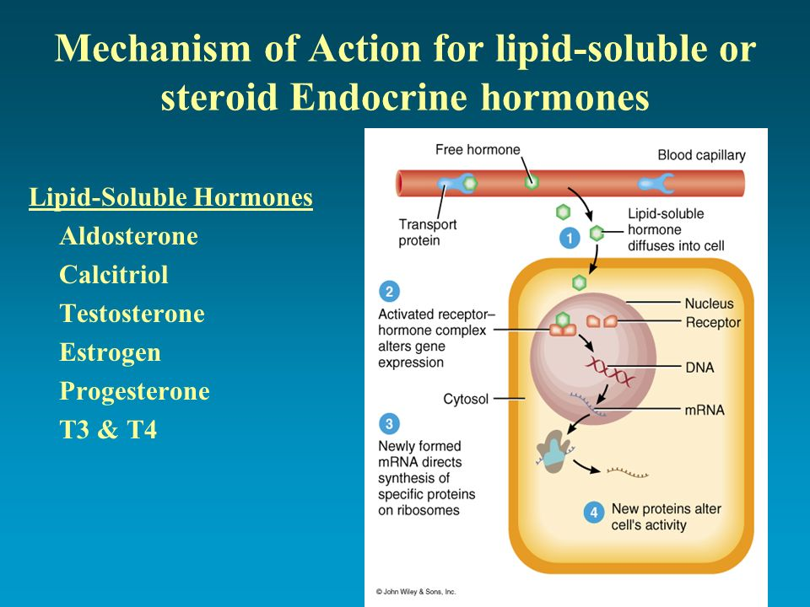
1 A free lipid-soluble hormone molecule diffuses from the blood, through interstitial fluid, and through the lipid bilayer of the plasma membrane into a cell.
2 If the cell is a target cell, the hormone binds to and activates receptors located within the cytosol or nucleus. The activated receptor–hormone complex then alters gene expression: It turns specific genes of the nuclear DNA on or off.
3 As the DNA is transcribed, new messenger RNA (mRNA) forms, leaves the nucleus, and enters the cytosol. There, it directs synthesis of a new protein, often an enzyme, on the ribosomes.
4 The new proteins alter the cell’s activity and cause the responses typical of that hormone.

Action of Water-Soluble Hormones
Because amine, peptide, protein, and eicosanoid hormones are not lipid-soluble, they cannot diffuse through the lipid bilayer of the plasma membrane and bind to receptors inside target cells. Instead, water-soluble hormones bind to receptors that protrude from the target-cell surface. The receptors are integral transmembrane proteins in the plasma membrane. When a water-soluble hormone binds to its receptor at the outer surface of the plasma membrane, it acts as the first messenger. The first messenger (the hormone) then causes production of a second messenger inside the cell, where specific hormone-stimulated responses take place. One common second messenger is cyclic AMP (cAMP). Neurotransmitters, neuropeptides, and several sensory transduction mechanisms (for example, vision; see Figure 17.16) also act via second-messenger systems. The action of a typical water-soluble hormone occurs as follows
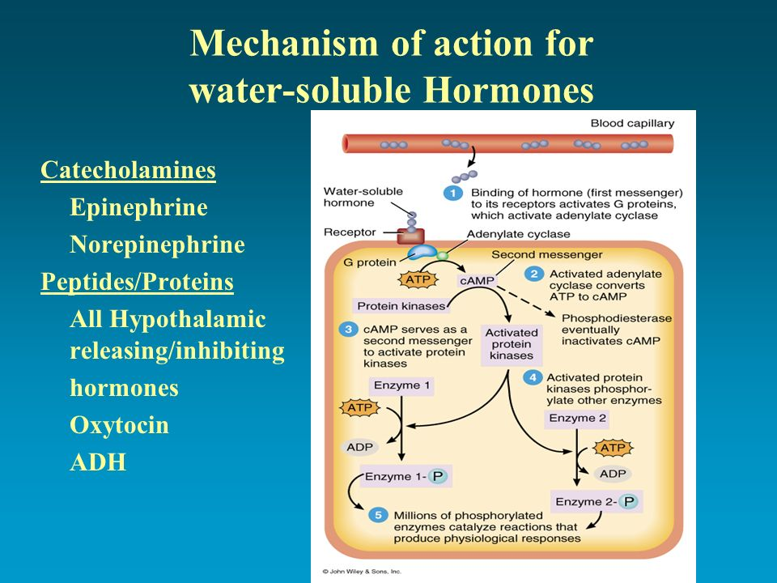
1 A water-soluble hormone (the first messenger) diffuses from the blood through interstitial fluid and then binds to its receptor at the exterior surface of a target cell’s plasma membrane. The hormone–receptor complex activates a membrane protein called a G protein. The activated G protein in turn activates adenylate cyclase molecule.
If each adenylate cyclase produces even 1000 cAMP, then 100,000 of these second messengers will be liberated inside the cell. Each cAMP may activate a protein kinase, which in turn can act on hundreds or thousands of substrate molecules. Some of the kinases phosphorylate and activate a key enzyme needed for glycogen breakdown. The end result of the binding of a single molecule of epinephrine to its receptor is the breakdown of millions of glycogen molecules into glucose monomers. Hormone Interactions
2 Adenylate cyclase converts ATP into cyclic AMP (cAMP). Because the enzyme’s active site is on the inner surface of the plasma membrane, this reaction occurs in the cytosol of the cell.
3 Cyclic AMP (the second messenger) activates one or more protein kinases, which may be free in the cytosol or bound to the plasma membrane. A protein kinase is an enzyme that phosphorylates (adds a phosphate group to) other cellular proteins (such as enzymes). The donor of the phosphate group is ATP, which is converted to ADP.
4 Activated protein kinases phosphorylate one or more cellular proteins. Phosphorylation activates some of these proteins and inactivates others, rather like turning a switch on or off.
5 Phosphorylated proteins in turn cause reactions that produce physiological responses. Different protein kinases exist within different target cells and within different organelles of the same target cell. Thus, one protein kinase might trigger glycogen synthesis, a second might cause the breakdown of triglyceride, a third may promote protein synthesis, and so forth. As noted in step 4 , phosphorylation by a protein kinase can also inhibit certain proteins. For example, some of the kinases unleashed when epinephrine binds to liver cells inactivate an enzyme needed for glycogen synthesis.
6 After a brief period, an enzyme called phosphodiesterase (fos-foˉ-d¯ı-ES-ter-aˉs) inactivates cAMP. Thus, the cell’s response is turned off unless new hormone molecules continue to bind to their receptors in the plasma membrane.
The binding of a hormone to its receptor activates many G-protein molecules, which in turn activate molecules of adenylate cyclase (as noted in step 1 ). Unless they are further stimulated by the binding of more hormone molecules to receptors, G proteins slowly inactivate, thus decreasing the activity of adenylate cyclase and helping to stop the hormone response. G proteins are a common feature of most second-messenger systems.
Many hormones exert at least some of their physiological effects through the increased synthesis of cAMP. Examples include antidiuretic hormone (ADH), thyroid-stimulating hormone (TSH), adrenocorticotropic hormone (ACTH), glucagon, epinephrine, and hypothalamic releasing hormones. In other cases, such as growth hormone–inhibiting hormone (GHIH), the level of cyclic AMP decreases in response to the binding of a hormone to its receptor. Besides cAMP, other second messengers include calcium ions (Ca2), cGMP (cyclic guanosine monophosphate, a cyclic nucleotide similar to cAMP), inositol trisphosphate (IP3), and diacylglycerol (DAG). A given hormone may use different second messengers in different target cells.

